

Tech Line: 1-561-863-2188

5410/5415 Front Strut Frame Installation
2”x3” Box Frame Rails and 1-5/8” Round Tube

These instructions are just one way of properly installing a strut front suspension. Depending on your fabrication experience, you may find it easier or more convenient using other methods that accomplish the same results. Every installation is slightly different, and we have attempted to structure these instructions to make your installation as easy as possible. Please read through and understand instructions prior to starting the installation.
Part # 5410/5415 (For use with Strange Engineering and most other race struts)
Start your installation by opening all packages and check the parts you have received against the parts list.
Parts list:
1... Strange Engineering Strut Package 2... 8 Inch Springs
2... 8’ Frame Rail Sections (Square or Round) 2... Upper Strut Bar Kits
1... Cross Members and Hardware (6023) 1... Rack Mount Kit (2701)
1… Steering Rack (2705) 1… Tie Rod Tube Kit (1900)

Before starting your installation, it is important that the car is in a location where it can remain undisturbed until the job is completed. Any flat surface, such as a garage floor is OK as long as it is flat and level. For the purpose of this installation, we will assume that the car has an existing aftermarket rear clip. There must be a cross member in place for either a ladder bar or 4-link suspension to base this front suspension off of.
INSTALLATION
• PREPARING THE CAR
- With the car at ride height, measure the distance to the ground in several locations. Block the car up so that this height can be maintained throughout the installation. Depending on ride height, it is preferable to do the installation with the car at the actual ride height. If needed, the car can be raised up to make the installation easier. You must add this dimension to all appropriate dimensions referenced in these instructions.
- Start by finding the centerline of the chassis, the rear axle and the front spindles. If, for some reason the car gets moved during installation, you will have these marks to correctly reposition the car later. Using a carpenter square and plumb bob, mark the rear axle center line on the floor and the fenders for future reference (See Figure 1). Begin by placing the square at the front edge of the wheel (rim) and mark the floor (1). Next, place the square at the back edge of the wheel and mark the floor (1). Half the distance between the two is the centerline of the axle (2). Now, hang the plumb bob from the wheel well opening, lining it up with the centerline on the floor. Mark the wheel well opening at this point. Now, you have the centerline of the axle marked on both the floor and the car. Repeat for the other side. Repeat for the front spindle centerline also. This will establish the correct wheelbase for the car once the original suspension is removed.
- Next, the centerline of the chassis from front to back needs to established. You will need to find two similar places on each side of the car, both in the front and rear of the car. In the front, drop the plumb-bob from one of the a-arm bolts on each side and find the center between the two. Mark the floor. In the rear, you can use the pinch welds on each side or even the center of the bumper will work. Mark the floor. After you have marked both locations snap a chalk line between the two.
- Now the center line of the motor and transmission need to be established. Hang the plumb-bob from the center of the crankshaft bolt and mark the floor. Do the same at the output shaft of the transmission. 12_3_2020 At this point you may want to do the same at the rear end yoke. With this mark and the crankshaft mark, you can check to see if the motor and transmission are in line with the pinion yoke. Now with all of the appropriate marks and measurements you can now start removing the original front suspension.
- Square Tube - After removing the original suspension, the installation of the front sub-frame can begin. Typically, the frame rail width should be 23” outside to outside. Using the carpenter’s square, measure from the center of the chassis at the rear cross member out 11-1/2 inches on each side of the centerline. Mark the cross member. This is where the outside of the new frame rails will be welded. Clamp a piece of flat steel to the bottom of the cross member at both points. This will help hold the rails in place. Set the rails on these temporary platforms and raise the front of the rails and set on blocks so that they measure 6” to the bottom at the approximate center line of the spindles. (See Figure 2). (If you have purchased the strut installation jig, now is the time to set it into place.) The frame rails will need to extend past the spindle centerline at least 24 inches.
5a. Round Tube - After removing the original suspension, the installation of the front sub-frame can begin. Typically, the frame rail width should be 22” outside to outside. Using the carpenter’s square, measure from the center of the chassis at the rear cross member, out 11 inches on each side of the centerline. Mark the cross member. This is where the outside of the new frame rails will be welded. Clamp a piece of flat steel to the bottom of the cross member at both points. This will help hold the rails in place. Set the rails on these temporary platforms and raise the front of the rails and set on blocks so that they measure 4-1/2” to 6” to the bottom at the approximate center line of the spindles (See Figure 2). (If you have purchased the strut installation jig, now is the time to set it into place.) The frame rails will need to extend past the spindle centerline at least 24 inches.
- Square Tube - If the rails will not rise to the 6” required, they will have to be cut at the firewall. (See Figure 2). Make a small pie cut in the top of the rails and raise the front to the required 6 inches (Square tube rails only). Using a level, make sure that both rails are at the same angle. Weld the seam and plate each side of the seam with 1/8” steel plate on both rails.
6a. Round Tube - If the rails will not rise to the 4-1/2 – 6 inches required, they will have to be bent at the firewall. (See Figure 2a). Make a small bend in the rails and raise the front to the desired 4-1/2 to 6 inches. Using a level, make sure that both rails are at the same angle. Sufficient roll cage support will be needed in this area of the frame rails.
- Check the width of the frame rails at the rear cross member and tack weld into place. Measure the inside of the frame rails at the front and cut a piece of tubing to make a temporary cross member for the front of the rails. Tack weld into place.
- Measure from the outside of the frame rails at the rocker panels just behind the firewall to make outriggers for each side of the car. Cut two pieces of tubing to fit. Cut and shape both ends of each piece of the tubing to fit the contour of the rocker panel and to match up with the frame rail. (It may be necessary to add a 1/8” thick plate on the rocker panel to add strength.) These two outrigger pieces will be where the front window bars of the cage will mount. (If you have existing window bars, they may need to be modified or replaced.)
- Now, the front window bars of the cage need to be installed or modified if pre-existing. If you are putting in new window bars they should go as close to the windshield pillar posts as possible. Tack the window bars in place on the frame outriggers that attach the frame rails to the rocker panels.
- Parallel support bars (rocker bars) should be made if they do not exist already. These two bars are made of roll bar material that run inside of the rocker panel connecting the frame outriggers to the rear suspension cross member. One on each side of the car is necessary.
• STRUT & STRUT BAR INSTALLTION
- Tack weld one strut support mounting post to the strut jig main rail, making sure that it is 90° in both directions. (Strut jig purchased separately or fabricated by customer) Place the strut jig under the frame rails on the spindle centerline with the mounting post on the driver side.
- Assemble the struts with the lower stud and steering arm and hub with bearings. (See Strange Engineering instructions supplied with struts.) Bolt the driver side strut to the mounting post on the jig by placing the spindle shaft through the hole in the mounting post and secure with the spindle nut. This enables the strut to be mounted at 0 degrees camber and set at 8-10° of caster while the upper and lower mounts can be made and placed into position.

- To make centering the strut jig somewhat easier, measure and mark a spot 1 inch in front of the spindle centerline at both ends. Snap a line between the two. Now you can line up the front edge of the jig instead of trying to center it on the original line. Please note that the strut mounting jig is designed for 24” tall tires. If you are using a taller tire, you will need to adjust for the difference by shimming the jig upward to make up the difference.
- With the strut mounted to the jig assembly and lined up with the spindle centerline, slide the jig towards the frame rail until you have a measurement of 16 inches from the outside of the frame rail to the wheel mounting surface of the strut hub. This distance can vary depending on the track width needed. Once this position has been established, tack weld a piece of scrap steel on each side from the frame rails to the strut jig to hold it all in place.
- To start assembling the passenger side, measure the distance from the driver side frame rail to the driver side mounting post. Place the passenger side mounting post at the same distance from the frame rail. Make sure that the mounting post is 90 degrees from front to back and side to side and tack weld into place.
- Mount the second strut to the jig as described earlier in the instructions. Check the track width after the strut is mounted. Use an angle finder on the steering arms to set the struts at 8-10° of caster. Both sides must be the same.
- Mark the outside of the frame rails 1-3/4” – 2” behind the spindle centerline. This will be the mounting point of the front tab of the rear control arms. (See Figure 3)
- Using the 1” tubes with tube adapters, install 2 of the ½” rod ends approximately ¾ of the way into the tube adapters. These will be used for your rear control arms.
- Install the lower strut knuckles on the lower strut studs. See Strange Engineering instructions for additional information. Align them so that the knuckle is in the middle of its travel. This makes the knuckle housing 90° to the strut stud. Take two of the control arm mounting brackets and trim to fit so that they align with the mark made on the side of the frame rail. They may be trimmed as much as ¾” from the hole in the tab. (Square tube). (See Figure 4). Round tube, using two of the notched tabs, trim until they fit the frame where it is marked. These tabs can rotate on the round tube as needed to aid in the installation (See Figure 4A). Bolt one of the brackets to each of the control arms through the rod ends. Make sure that the nut is on the tab side of the assembly.
- Hold the control arm assembly up to the frame rail with the tab facing the front of the car and in line with the mark on the frame rail. With the control arm and tab in place, mark the control arm tube even with the shoulder on the knuckle. It is very important that the knuckle is in the middle of its travel from front to back and side to side. Cut the tube a little long incase you have to adjust this. After this tube has been trimmed to fit, cut the other side (passenger) the same length.
- Slide the control arm tubes on to the knuckles. Line up the control arms on to the frame and tack weld the brackets into place even with the top of the frame rails (square tube). Make sure that the tab is parallel with the control arm and the rod end ball is centered in its travel. Round tube, you can rotate the tab on the tube to aid in alignment. Cut two more of the control arm mounting tabs to fit on the other side of the rod ends so that they contact the frame rail parallel with the control arm. Remember, they will be longer than the first ones (See Figure 3, 4 and 4A). Tack the tabs into place. Do not tack the control arms to the knuckles at this time.
- Start the installation of the front control arms by measuring 14” forward of the spindle centerline on the outside of both frame rails and mark it. (See Figure 3). This where the rear bracket of the front control arms will mount. Round tube rails may have to have these tabs moved up on the strut support tube (See Figure 4A).
- Using the 7/8” tubes with tube adapters, install 2 of the ½” rod ends approximately ¾ of the way into the tube adapters. These will be used for your front control arms.
- Take two more of the control arm mounting brackets and trim to fit so that they are pointing at the strut knuckle. This may be as much as 7/8” from the hole. (See Figure 4 & 4A). Bolt one of the brackets to each of the control arms. Make sure that the nut is on the tab side of the assembly.
- Hold the control arm assembly up to the frame rail with the tab facing the rear of the car and in line with the mark on the frame rail and 1/2” down from the top of the frame rail. Round tube, move tabs as necessary to achieve and mark the ¼ -1/2” lower mounting height when compared to the rear control arm tabs. (See Figure 3, 4 & 4A). With the control arm and bracket positioned correctly, mark the control arm tube even with the shoulder on the clevis end attached to the knuckle. It’s very important that you check to make sure that the knuckle is in the middle of its travel from front to back and side to side. Cut the tube a little long incase you have to adjust the length of the front control arm. After this tube has been trimmed to fit, cut the other side (passenger) the same length.
- Slide the control arm tubes on to the clevis end, on the knuckle. Re-line up the control arms on the frame so that the control arm brackets are ½” lower than the top of the frame rail (Lower than the rear tab holes). Make sure that the tab is parallel with the control arm and the rod end ball is centered in its travel. Tack weld tabs into place. (See Figure 3 & 4). For round tube installations, the forward tabs will typically mount on the strut support tube. (See Figure 4A). Cut two more of the control arm mounting tabs to fit on the other side of the rod ends so that they contact the frame rail parallel with the control arm. Remember, they will be longer than the first ones. Tack these into place. Do not tack the control arms to the clevises at this time.
- Bolt the Upper Strut Cups to the stem of the struts. The flat at the bottom of the strut cups go between the two black bushings on the top of the strut and is held in place by a washer and nut. To make removing and re-installing the nut easier cut a piece of tubing as a spacer so that the nut does not need to be threaded all of the way on to make the assembly tight.
- Once the upper strut cups are in place on the struts, open the struts up so there is a ½” of shaft showing below the bump stop. Make the sure the bump stop is pushed up into the spring cap where it belongs. This will set the strut travel in its proper ride height.
- Cut and fit the upper front strut bars to fit from the A-pillar bars of the cage, even with the dash bar, to the cups on top of the struts and tack into place. Next, take the shorter sections of the strut bars and fit to the frame and the front side of the strut cups. These front strut bars should go to the area on top of the frame rails in front of the front strut control arm brackets. Double check to make sure that the struts are at their proper ride height and tack weld the bars and mounts into place. When welding the upper strut mounts, take care not to melt the rubber bushings.
- Use a piece of 1-3/8” tubing to create a brace for both sides that run from the front strut bar, just behind the upper strut mount cup, down to the frame rail just in front of the mid plate mount. Fit and tack weld into place on both sides.
• Rack and Pinion Installation
- Tie a string from one steering arm to the other using the holes in the end of the arms for the tie rod tubes. Stand a square on top of each frame rail sliding it up to the string and mark the top of each frame rail at that location. Using the square again, draw a line across the top and down the inside of each frame rail. These marks will be called the “steering centerline” and used to locate the rack and pinion cross member.
- Draw a line on the inside of the frame rails ¼” to the front side of the steering centerline marks. This line is where the front edge of the rack cross member will be located. The top of the cross member will line up with the top of the frame rails. (See Figure 5).
- Cut a piece of 1-3/8” x .095 tubing to fit tightly and square between the frame rails. Find and mark the center of the crossmember. Place the cross member on a work bench and mark the cross member to the right of the centerline at 8-5/8”. Now measure to the left of the centerline 6-1/2” and mark it. (See Figure 6).
- With the cross member on the bench weld the rack mount brackets. With the brackets pointing toward you, line up the holes in the brackets with the left and right lines on the cross member. The mounting surfaces will be up and the gusset sides will face the center of the car. Tack weld into place. Double check all measurments, test fit the rack if you feel necessary and the squareness of the brackets and finish welding into place.
- Using the lines on the inside of the frame rails, slide the rack cross member into the proper location. Rotate the cross member so that the rack mount brackets are pointing up towards the front of the car at approximately 25 degrees and tack weld into place. (See Figure 5 & 6). This angle is just a starting point. Clearence for motor, headers, tanks, etc. have to be considered in the angle of the rack and pinion steering shaft. Remember that the mounting brackets should be closer to the drivers side frame rail. Trial fit the rack and pinion using the Rack Mount Kit. P.N. 2701. Make sure that everything is in place, square and lines up correctly. If satisfied with placement, move on to next step. Otherwise break the tacks and make adjustments necessay then re-tack weld into place.
• Rack and Pinion Installation
- Before measuring the length of the tie rods, bolt the rack and pinion into place. It will have to be centered from tie rod end to tie rod end. This can be done by turning the input shaft of the rack and pinion with a pair of vice grips or pliers from lock to lock counting the turns. Then turn the shaft one half of the distance back from the lock position and the rack and pinion will be centered.
- Check that the wheels are pointing straight ahead by measuring from the frame to the tire at the front and back on each side.
- Screw a 7/16" rod end into each of the tie rod tubes, 2/3 of the way. Slide the new tie rods over the stock tie rods on the rack and pinion. If the tie rods will not slide on far enough to line up the rod ends with the holes in the steering arms on the spindles, the rack and pinion tie rods will have to be shortened. Don’t cut any more than is needed. (The new tie rods should slide over the steering rack tie rods a minimum of 2-1/2 inches) Once the proper length has been determined cut the inner end of the tie rod tube kit at an angle. Next, drill two holes into the tubes opposite of each other, just short of the end of the rack and pinion tie rod ends. See drawing supplied with the Tie Rod Tube Kit, P.N. 1900.
- Bolt the rod ends to the arms on the spindles after the tubes are slid over the tie rods on the rack and pinion. The tie rod assemblies should be the same angle as the lower control arms. Bolt the assembly to the top or bottom of the steering arms and add a spacer to achieve the proper angle, if needed. See drawing supplied with strut instructions. Check that the wheels are still pointing straight ahead before welding the holes in the tubes and the ends of the tubes. NOTE: Slide the end of the boots in a far as possible to the inside before welding so the boots don’t melt.
- Make final alignment adjustments and tighten all nuts and bolts.
- The installation of your strut front end is now almost complete. Check all of your measurements, angles and all cross members for square and level placement. Once you are satisfied that everything is properly placed, finish welding and check all nuts and bolts. Remove all temporary supports. Your installation is now complete.

SPECIAL NOTES:
• Do not do your final welding with rod ends in place.
• Remove anything that is made of rubber before final welding in that area.
• Remove Struts before final welding.
• Melted rubber, fused rod ends and damaged struts due to welding or weld splatter
will not be replaced or warranted.

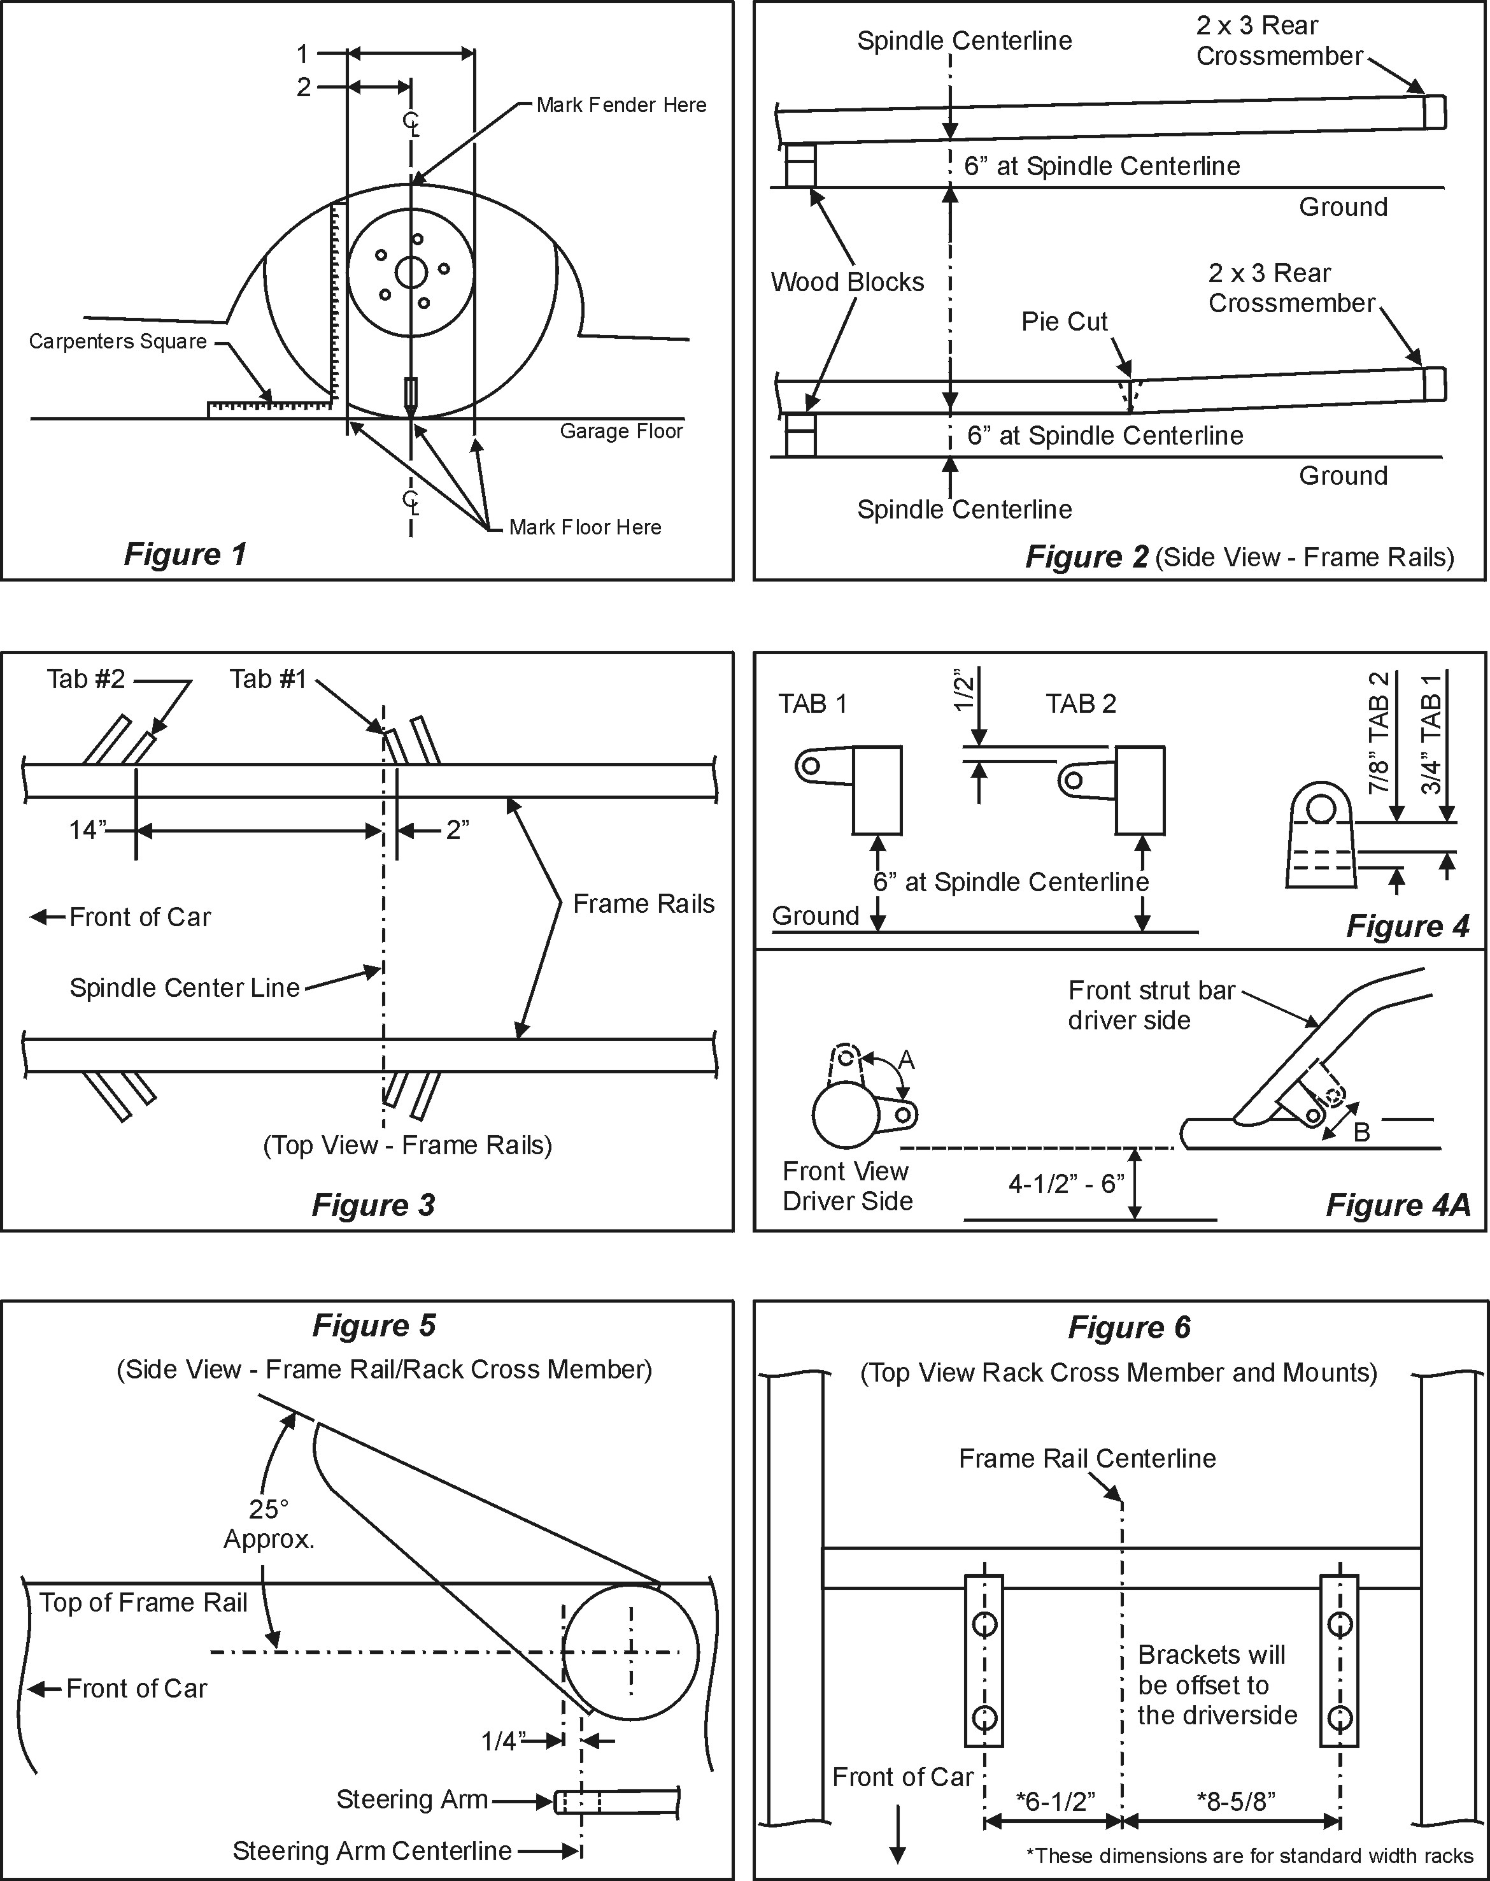

5410/5415 • Strut Cup Addendum

